The Creative Communities Scheme (CCS) assessment committee allocates CCS funding for our city. The committee is made up of councillors and community representatives who are familiar with the broad range of local arts activity. Assessors who are community representatives can sit on the committee for a maximum of 2 x 3-year terms.
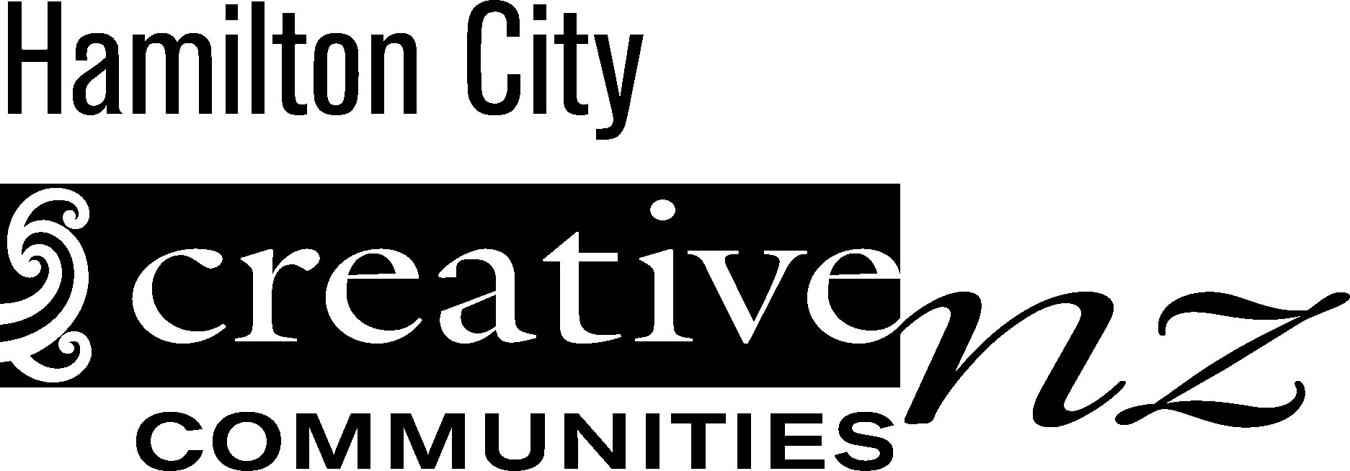
Name of nominee

Address
Email
Phone
Please mark the artforms that you have expertise in with an X:
 | Craft/object art |  |  |  | Dance |  | Inter-arts
 | Literature |  |  |  | Music |  | Ngā toi Māori
 | Pacific arts |  |  |  | Multi-artform (including film) |  | Theatre
 | Visual arts
What other skills or knowledge would you bring to the assessment committee eg assessment skills, knowledge of a particular community, etc?

Name of person making nomination

Email
Phone
Date

